**Java Foundations**

**Section-6**

Section 3

**1.**

**package** pin;

**import** java.util.Scanner;

**public** **class** Pin {

**public** **static** **void** main(String[] args) {

**int** validPin = 1234;

Scanner scanner = **new** Scanner(System.***in***);

System.***out***.print("Enter your PIN: ");

**int** enteredPin = scanner.nextInt();

**while** (enteredPin != validPin) {

System.***out***.print("Invalid PIN. Try again: ");

enteredPin = scanner.nextInt();

}

System.***out***.println("Correct PIN entered. You now have access to your account.");

}

}

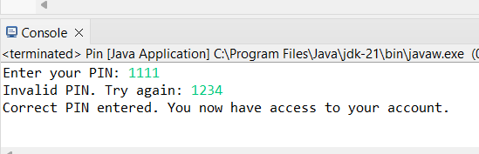

**2.**

**package** multiple;

**import** java.util.Scanner;

**public** **class** Multiple {

**public** **static** **void** main(String[] args) {

// Create a Scanner object to read user input

Scanner scanner = **new** Scanner(System.***in***);

// Prompt the user to enter a number

System.***out***.print("Choose a number: ");

// Read the user's input and store it in a variable

**int** number = scanner.nextInt();

// Use a for loop to display the multiples of the number from 1 to 12

**for** (**int** i = 1; i <= 12; i++) {

**int** multiple = number * i;

System.***out***.println(number + "x" + i + " = " + multiple);

}

}

}

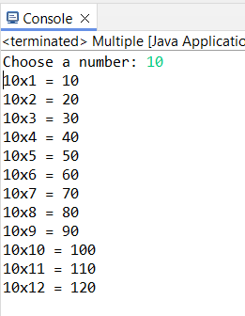

**3.**

**package** loopshape;

**public** **class** Loopshape {

**public** **static** **void** createRectangle(**int** width, **int** height) {

**if** (width < 1 || height < 1) {

System.***out***.println("Cannot draw a shape with a dimension less than 1.");

**return**;

}

// Print the top border

**for** (**int** i = 0; i < width; i++) {

System.***out***.print("#");

}

System.***out***.println();

// Print the middle rows

**for** (**int** i = 0; i < height - 2; i++) {

System.***out***.print("#");

**for** (**int** j = 0; j < width - 2; j++) {

System.***out***.print(" ");

}

System.***out***.println("#");

}

// Print the bottom border

**if** (height > 1) {

**for** (**int** i = 0; i < width; i++) {

System.***out***.print("#");

}

System.***out***.println();

}

}

**public** **static** **void** createTriangle(**int** size) {

**if** (size < 1) {

System.***out***.println("Cannot draw a shape with a dimension less than 1.");

**return**;

}

// Print the triangle

**for** (**int** i = 0; i < size; i++) {

**for** (**int** j = 0; j <= i; j++) {

System.***out***.print("#");

}

System.***out***.println();

}

}

**public** **static** **void** main(String[] args) {

*createRectangle*(5, 4);

System.***out***.println();

*createTriangle*(5);

}

}

